Name: | ___________________________________________________ |  | Date: ___________
 | Year 10 General  Test 6, 2015  Topic – Probability |  | 43  = %
Total Time:60minutes

Total Reading: 5 minutes

Total Working: 55 minutes

Weighting: 5 % of the year.

Equipment Allowed: 1 page notes (A4 both sides), Scientific calculator
CALCULATOR ALLOWED ONLY

1. | [4 marks: 1, 1, 1, 1 ]
 | A bag contains 20 balls. Six are green, nine are blue and the rest are white. If one ball is chosen at random from bag, find the probability that it is
a)  b)  c)  d) | Green  White  Green or white  Blue
2. | [6 marks: 1, 1, 2, 2]
 | In the Venn diagrams below, shade the region representing

a) | _  A  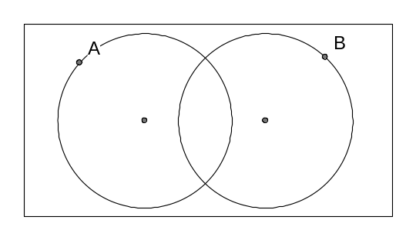

b)  c)  d) | A | B  ______  A ∩ B  __  A U B

3.  a)  b)  4.  a)  b)  5. | [5 marks: 1, 4]  Two normal dice are rolled at the same time.  How many elements are there in the sample space?  Find the probability of the following evens:  - Pr(total of 5)  - Pr(total less than 11)  - Pr(at least one even number in the pair)  - Pr(no prime numbers in the pair)  [4 marks: 2, 2]  A prime number die has numbers 2, 3, 5, 7, 11 and 13 on it. Two such dice are thrown. What is a probability that:  the sum shown is even.  the number on one die is larger than the number on the other.  [3 marks]
In a class of 24 students there are 10 students with at least one parent who was born overseas, 7 students who are fluent in second language and 4 who speak a second language and have at least one parent who was born overseas.

Let B = { a parent born overseas} and,
L = { fluent in second language}

Display this information as a Venn Diagram

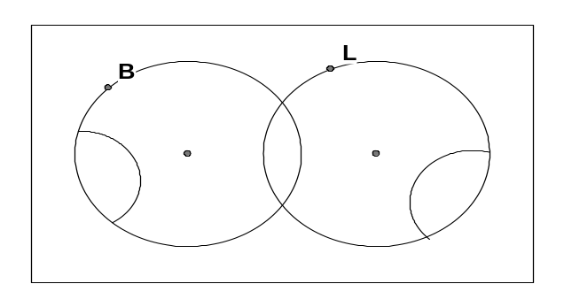

6. | [6 marks: 4, 1, 1]
Given that U = { x | 1≤ x ≤ 10, x is an integer}, A = { x | x is a prime number},
B = { x | x is a square number} and C = { x | x is a multiple of 3}.

a) | U = {  A = {  B = {  C = {
b)  c)  7.  a)  b)  c) | Find A ∪ B  Find B ∩ C  [5 marks: 2, 2, 1]  A test had 3 true-false questions and 2 multiple choice questions with options A, B, C and D. Only one answer is correct for each question.  What is the probability of guessing all 5 questions correctly?  What is the probability of guessing 2 of the true-false questions and 1 of the multiple choice questions correctly?  What is a probability of getting them all wrong?
8. | [10 marks: 4, 1, 1, 2, 2]
a) | Sam has 12 cards numbered 1 to 12. She draws 2 cards, one after another, without placing them back.  Let P = {number divisible by 3} and N = {number not divisible by 3}  Draw a tree diagram to show this information.
b)  c)  d)  e)  9.  a)  b) | Find Pr(both cards show a number divisible by 3)  Find Pr(no cards show a number divisible by 3)  Find Pr(at least one card shows a number divisible by 3)  Find Pr(first card is divisible by 3 given that the second card is not divisible by 3)  [7 marks: 2, 1, 2, 2]  In a survey of 120 people, it was found that 80 people like hamburgers, whereas 60 people liked sausages. 4 people said they dislike both.  Present this information in a two-way table.  If one person is chosen at random, find the probability, as a percentage, that the person:  i) Likes sausages only.  ii) Likes hamburgers or sausages but not both.  iii) Likes sausages given that the person does not like hamburgers.  ~END OF TEST~

